Journal of Integrative Medicine 19 (2021) 129–134

Contents lists available at ScienceDirect

Journal of Integrative Medicine

j o u r n a l h o m e p a g e : w w w . j c i m j o u r n a l . c o m / j i m

w w w . j o u r n a l s . e l s e v i e r . c o m / j o u r n a l - o f - i n t e g r a t i v e - m e d i c i n e

Original Research Article

Using weighted blankets in an inpatient mental health hospital to decrease anxiety

Annette L. Becklund ^{a,⇑}, Lisa Rapp-McCall ^{b}, Jessica Nudo ^{b}
- Annette L Becklund, MSW, LCSW & Associates LLC, PO Box 3870, Spring Hill, FL 34611, USA

- Saint Leo University, Saint Leo, FL 33574-6665, USA

a r t i c l e i n f o

Article history:

Received 30 May 2020

Accepted 13 October 2020

Available online 28 November 2020

Keywords:

Weighted blanket

Anxiety

Mental health

a b s t r a c t

Objective: Patients who are involuntarily committed to a psychiatric facility often experience anxiety or increased anxiety in response to being placed in the institutional environment. The weighted blanket introduced a proactive treatment option. The purpose of this study was to evaluate patients’ anxiety symptoms before and after weighted blanket, compared to a group that did not use a weighted blanket to control anxiety.

Methods: This study was conducted in an inpatient mental health facility from June 10, 2019, through November 7, 2019, with psychiatric patients who were not actively psychotic. Participants were offered the choice of weighted or unweighted blankets for a 20-minute intervention. The treatment group was comprised of individuals who had opted to use a 14-pound weighted blanket, 20-pound weighted blan-ket or 5-pound weighted lap pad. Participants in the comparison group were active in a wider range of settings. Before application of the blankets, pulse rate was measured using a pulse oximeter, and anxiety was measured using the Spielberger State-Trait Anxiety Inventory shortened form (STAI: Y-6). Both mea-sures were taken again after the intervention. A two-way mixed analysis of variance (ANOVA) was run to examine the interaction effects between time (pre/post) and group (comparison/weighted blanket). Simple main effects were then further examined for the comparison/weighted blanket groups using a repeated measures ANOVA. Within the weighted blanket group, additional two-way mixed ANOVA was run to determine if gender or blanket weight made a statistically significant difference.

Results: There was a statistically significant difference (P < 0.05) among those who used weighted blan-kets (n = 61) and those who did not (n = 61) based on the pre/post data for both the STAI: Y-6 inventory and the patients’ pulse rates. The results of two-way ANOVA indicated a significant interaction effect between intervention time and group (P < 0.001). Repeated measures ANOVA indicated a change between pre/post for the weighted blanket group only, and showed significant reductions in both the STAI: Y-6 (P < 0.001) and pulse rates (P = 0.040). Within the weighted blanket group, additional two-way mixed ANOVA showed that neither gender nor blanket weight had significant difference for either the STAI: Y-6 or the pulse measures.

Conclusion: The use of weighted blankets is a safe and potentially effective way to help individuals in a psychiatric facility manage anxiety. This study found a statistically significant drop in anxiety for adults at an inpatient facility, as shown by the STAI: Y-6 scores and drop in pulse rates among patients using weighted blankets. This study suggests a possible alternative to medications, seclusion and physical restraints, which are not patient-centered or trauma-supported.

Please cite this article as: Becklund AL, Rapp-McCall L, Nudo J. Using weighted blankets in an inpatient mental health hospital to decrease anxiety. J Integr Med. 2021; 19(2):129–134.

2021 Shanghai Changhai Hospital. Published by ELSEVIER B.V. All rights reserved.

⇑ Corresponding author.

E-mail address: annettelbecklund@gmail.com (A.L. Becklund).

1. Introduction

Anxiety is the most common mental health problem in the United States [1]. Although anxiety is not the primary admitting diagnosis for inpatient mental health facilities, patients often

https://doi.org/10.1016/j.joim.2020.11.004

2095-4964/ 2021 Shanghai Changhai Hospital. Published by ELSEVIER B.V. All rights reserved.

A.L. Becklund, L. Rapp-McCall and J. Nudo

demonstrate anxiety symptoms and behaviors, including irritabil-ity, difficulty controlling worry, difficulty falling asleep or staying asleep, restlessness, difficulty concentrating and feeling edgy or wound up [2]. Exhibition of anxious behaviors often leads to the administration of medications meant to sedate a patient. Anxious behaviors can also lead to the use of restraints and seclusion, which can be traumatic experiences for patients [3].

A weighted blanket is a therapeutic blanket that includes weighted material designed to provide proprioceptive input to the body. Proprioception, sometimes referred to as the ‘‘sixth sense,” is related to body position and movements [4]. Weighted blankets provide deep touch pressure stimulation, which has both physical and psychological advantages [5]. Deep pressure stimula-tion (DPS) affects the nervous system by increasing serotonin and melatonin concentrations while decreasing cortisol levels. This cre-ates a calming effect, which may minimize stress, induce sleep and increase feelings of well-being [6].

The first exploratory study of weighted blankets by Mullen et al.

- used a convenience sample of 32 non-hospitalized, heteroge-neous individuals and the application of a 30-pound weighted blanket for 5 min. Participants were consenting, voluntary adults between the ages of 18 and 64, who were not hospitalized and had no apparent medical conditions or physical injuries. Partici-pants were randomly assigned to one of two groups, which deter-mined their assignment to either the control or treatment sessions. Sessions were 5 min in duration, with a 5-minute break between the two to complete the Spielberger State-Trait Anxiety Inventory (STAI-10) questionnaire [6]. The 5-minute timeframe for the ses-sions was selected based on Grandin’s findings, which indicated that this was enough time to produce calming effects in children when using DPS [7]. It was also noted that results were often observable within minutes of a DPS intervention in adult popula-tions in mental health settings.

The study took place in a nursing resource room where auditory interruptions in the testing environment were controlled, and a consistent temperature ranging between 72 and 75 degrees Fahrenheit was set. The room was designed to replicate a hospital setting and create a controlled environment that would allow for comparison to future studies conducted in various environments. Participants were introduced to the test environment, where the procedures were explained. They were provided the opportunity to ask questions before agreeing to participate in the study and signing the consent form. All participants were tested while lying down, and blood pressure, skin conductance, pulse rate and oxime-try data were monitored throughout the sessions [6].

The study explored both safety and therapeutic effects in a rel-atively healthy population with low anxiety. Based on the popula-tion, it was hypothesized that the blanket effects would be minimal and that no safety concerns would be identified. The results indicated the weighted blanket was safe and that it did decrease anxiety, as average participants scored lower on their STAI-10 after using the blanket, even in a population that was gen-erally characterized as ‘‘low anxiety” [6].

A pilot study conducted by Champagne et al. [8] consisted of a consecutive sample of 30 heterogeneous adults between the ages of 18 and 64 in an inpatient mental health facility. Exclusion crite-ria included impaired cognitive functioning, physical injuries, a positive pregnancy test and illiteracy. Participants were randomly assigned to one of two groups, which determined whether they would participate in the control or treatment sessions [8]. The study took place in the private rooms of participants staying in a 24-bed, locked, acute care mental health unit. The rooms had a standard temperature range of 65–79 degrees Fahrenheit with a privacy screen to reduce external stimulation. The STAI-10 survey and self-report anxiety rating were taken before participants lay down and after the 5 minutes was concluded. During the interven-
Journal of Integrative Medicine 19 (2021) 129–134

tion, participants in the treatment group used a 30-pound weighted blanket for 5 min. Participants’ blood pressure, pulse rate and oximetry data were monitored throughout the sessions [8].

Participants with blood pressure and pulse rates outside the normative range remained consistent during both treatment and control sessions. Additionally, the results indicated a positive effect of the weighted blanket use, with 60% of participants having a decrease in anxiety, as determined by the survey and analysis of physical measurements. This study indicated the need for future studies to explore client-centered methods that are effective and evidence-based and that would also encourage the reduction in use of restraints [8].

Studies of the use of weighted blankets have begun to show the blankets potential in reducing anxiety, providing a proactive treat-ment alternative to restraints, seclusion and medication that causes sedation and side effects. However, there have been very few studies to date, and both used the weighted blankets for very short intervals. The purpose of the current study was to identify if there was a significant difference in anxiety symptoms before and after weighted blanket use for adults in an inpatient mental health facility.

2. Methods and materials

2.1. Study setting

The study was conducted in three units of a 66-bed inpatient mental health facility: (1) the critical care unit, where patients were involuntarily committed or voluntarily committed knowing they were a danger to themselves or others; (2) the drug/alcohol unit, where patients were being treated for drugs and/or alcohol addiction; (3) the older adult unit, where individuals were gener-ally over the age of 60 and/or had a developmental disability or limited mobility. All three units were locked. There was no control of the temperature or of any environmental factors such as noise or interruptions. The patients who used the weighted blankets were lying down in their beds in their bedrooms. The comparison group members used a wider range of settings, and were in their bed-room, lying down or sitting on their bed, or in the recreation room, common area, lunchroom or attending group therapy.

2.2. Characteristics of weighted blankets

There were two sizes of weighted blankets and one size of lap pad. Weighted blankets weighed either 14 or 20 pounds each and mea-sured 1828.8 mm by 1066.8 mm (enough to cover a person on a twin-size bed). Weighted lap pads weighed 5 pounds and were 355.25 mm by 477.75 mm. The blankets, which were specifically made for medical facilities, and the lap pads were made with vinyl exteriors so that they could be cleaned with sanitizing wipes after each use, and were weighted with glass beads [9]. Recommended use for such blankets specifies that the blanket should be approxi-mately 10% of a person’s body weight. Previous studies utilized a 30-pound blanket, with a shorter application duration [6,8].

2.3. Participants

Participants were adult patients who had been admitted to the mental health facility and were housed in one of the three units mentioned above. Patients were awake and oriented, knew the time of day and were legally able to sign a consent form for treat-ment. The study was open to all races, genders and ethnic groups and was not focused on any specific demographic. Participants with any diagnosis were eligible to participate in the study. Exclu-sion criteria were patients who were actively psychotic (and/or not

130

A.L. Becklund, L. Rapp-McCall and J. Nudo

oriented to person, place, or time). The sampling strategy was pur-posive, judgmental and theoretical. The sample size was calculated by setting the confidence level at 95%, the confidence interval at 9, and the population number as unknown. This resulted in requiring at least 119 participants total in the study. The sample was 61 in the weighted blanket group and comparison group respectively, a total of 122 participants.

2.4. Measures

Pulse rates were obtained using a fingertip pulse oximeter. Pulse rate is useful not only for ensuring patient safety but also as a measure of anxiety [8].

The STAI is the Spielberger State-Trait Anxiety Inventory, and the STAI: Y-6 is a shortened form of the STAI with strong psycho-metric properties and good reliability and validity [8]. For the pur-poses of the study, the STAI: Y-6 was used, as the longer version was considered unmanageable for this setting [10]. The shortened form has been found to produce similar scores to the full form and is still sensitive to changes in state anxiety [10]. Scoring produces an overall state anxiety score for an individual, with a higher score indicating more anxiety.

2.5. Procedures

A non-equivalent group design was used because randomiza-tion was not possible. Approval from the Saint Leo University Insti-tutional Review Board was obtained on May 29, 2019. Patients who exhibited signs of anxiety or expressed anxiety were approached by a licensed clinical social worker or a supervised master of Social Work Student Intern and invited to take part in the study. The pro-cedures and consent form were explained to the patient, and if they elected to be in the study, they signed and kept a copy of the form. Data were collected in duplicate format. One copy was retained in the patient’s chart. The second copy was assigned a number for anonymity. Sex, age and diagnosis of each patient were noted. Start and end time of study sessions was recorded.

First, the patient’s pulse rates were measured and recorded. Then the six questions from the STAI: Y-6 were asked of the patients, and their answers were recorded. If the patient chose to use the weighted blanket, the blanket’s weight was noted (20 pounds, 14 pounds, or 5-pound lap pad). A sheet was placed over the patient. The weighted blanket was placed over the legs and torso of patient while they were lying in their beds. A light blanket was placed over the weighted blanket to conceal the vinyl exterior from other patients. The researcher remained present for a 20-minute period, during which the blankets remained in place. Fol-lowing the treatment, the STAI: Y-6 was re-administered, and the pulse rate was measured and recorded.

Patients who did not want to use a weighted blanket followed the same data collection procedure but did not use a weighted blanket (nor any other intervention), and primary outcome data were again collected after the 20-minute treatment period.

2.6. Data analysis

A two-way mixed analysis of variance (ANOVA) was used to examine the interaction effects between time (pre/post) and group (comparison/weighted blanket). Simple main effects were then further examined for the comparison/weighted blanket groups using a repeated measures ANOVA. Within the weighted blanket groups, additional two-way mixed ANOVA was run to determine if gender or blanket weight made a statistically significant differ-ence. A two-way mixed ANOVA was run on the pre- and post-intervention scores for both the STAI: Y-6 and the participants’ pulse rates. For the STAI: Y-6, the data were transformed using a
Journal of Integrative Medicine 19 (2021) 129–134

log transformation to address homogeneity of variance. Data were analyzed using IBM SPSS version 26.

3. Results

3.1. Baseline characteristics of participants

The mean ages of both the weighted blanket group and the comparison group were comparable. One hundred and twenty-two patients with the mean age of 39.5 years participated in the study. The mean age of the comparison group was 39.2 years, and the mean age of the weighted blanket intervention group was 39.8. Males totaled 35.2% and females 64.8% of the weighted blanket intervention group, while the comparison group was com-prised of 37.7% males and 62.3% females.

The primary diagnoses for patients were depression and bipolar disorder (Table 1). Approximately 60% had no secondary diagnosis listed on their paperwork. Twelve had an ‘‘other” category, which may have included, but was not limited to substance-related disor-ders and various other categories within the Diagnostic and Statis-tical Manual of Mental Disorders. Four participants had generalized anxiety disorder as a secondary diagnosis. Two partic-ipants had a secondary diagnosis of post-traumatic stress disorder. Two of the participants had a secondary diagnosis of autism or a developmental disability. There were no significant differences across any demographics for the weighted blanket intervention and comparison groups.

3.2. Clinical response

Before application of the blanket intervention, there was no dif-ference between pulse rates of patients in the treatment and com-parison groups (t = 0.41, P = 0.681; Table 2). However, there was a significant difference between the pre-intervention STAI: Y-6 scores of the two groups (t = 2.03, P = 0.044; Table 3), with the treatment group showing higher anxiety than the comparison group.

There was a statistically significant interaction effect between the pre- and post-intervention scores on the STAI: Y-6 and use of a weighted blanket (F_{[1,120]} = 55.745, P < 0.001, partial g² = 0.317; Fig. 1). There were no outliers identified when examined by the stu-dentized residual values outside >±3. There was homogeneity of covariance as assessed by Box’s test of equality (P = 0.152) and homo-geneity of variance as assessed by Levene’s test (P > 0.05).

A further examination of simple main effects revealed no signif-icant effect across pre- and post-intervention STAI: Y-6 measures for the comparison group (F_{[1,60]} = 0.560, P = 0.457, partial g² = 0.009). However, there were simple main effects for the weighted blanket group (F_{[1,60]} = 76.696, P < 0.001, partial g² = 0.561). When looking specifically at the weighted blanket group, no significant interaction effects were found by gender (F_{[1,59]} = 1.663, P = 0.202, partial g² = 0.027; Fig. 2) or blanket weight (F_{[2,58]} = 1.461, P = 0.240, partial g² = 0.048; Fig. 3).

There was a statistically significant interaction effect between the pre- and post-intervention pulse rates and the use of a weighted blanket (F_{[1,117]} = 4.332, P = 0.040, partial g² = 0.036; Fig. 4). There were no outliers identified when examined using the studentized residual values outside ± 3. There was homogeneity of covariance, as assessed by Box’s test of equality (P = 0.513) and homogeneity of variance, as assessed by Levene’s test (P > 0.05).

A further examination of simple main effects revealed no signif-icant effect across pre- and post-intervention pulse rates for the non-weighted blanket group (F_{[1,59]} = 0.087, P = 0.769, partial g² = 0.001). However, there were simple main effects for the weighted blanket group (F_{[1,60]} = 76.696, P < 0.001, partial g² = 0.561). When looking specifically at the weighted blanket

131

A.L. Becklund, L. Rapp-McCall and J. Nudo |  |  |  |  |  |  |  |  |  | Journal of Integrative Medicine 19 (2021) 129–134
Table 1
Demographics.
Item |  | Total (n = 122) | Comparison group (n = 61) |  |  |  |  | Weighted blanket group (n = 61) |  |  | Significance
Gender (n [%]) |  |  |  |  |  |  |  |  |  |  | v² = 0.323, P = 0.570
Male |  | 43 (35.2%) | 23 (37.7%) |  |  |  | 20 (32.8%)
Female |  | 79 (64.8%) | 38 (62.3%) |  |  |  | 41 (67.2%)
Diagnosis (n [%]) |  |  |  |  |  |  |  |  |  |  | v² = 2.619, P = 0.758
Bipolar |  | 45 (36.9%) | 24 (39.3%) |  |  |  | 21 (34.4%)
Depression |  | 48 (39.3%) | 22 (36.1%) |  |  |  | 26 (42.6%)
Schizoaffective |  | 14 (11.5%) | 6 (9.8%) |  |  |  | 8 (13.1%)
Schizophrenia |  | 5 (4.1%) | 4 (6.6%) |  |  |  | 1 (1.6%)
Substance abuse |  | 2 (1.6%) | 1 (1.6%) |  |  |  | 1 (1.6%)
Other |  | 8 (6.6%) | 4 (6.6%) |  |  |  | 4 (6.6%)
Age (mean ± SD) |  | 39.5 ± 13.9 | 39.2 ± 13.1 |  |  |  | 39.8 ± 14.7 |  |  |  | t = 0.228, P = 0.820
Blanket weight (n [%]) |  |  |  |  |  |  |  |  |  |  | –
5 pounds |  | – | – |  |  |  | 6 (9.8%)
14 pounds |  | – | – |  |  |  | 40 (65.5%)
20 pounds |  | – | – |  |  |  | 15 (24.6%)
SD: standard deviation.
Table 2
Pulse scores at pretest.
Group | n | Pulse (mean ± SD, beats/min) |  | P value
Comparison | 61 | 89.03 ± 13.07 |  | 0.681
Weighted blanket | 61 | 87.97 ± 15.23
SD: standard deviation.
Table 3
STAI: Y-6 scores at pretest.
Group | n | STAI: Y-6 score (mean ± SD) |  | P value
Comparison | 61 | 43.24 ± 14.15 |  | 0.044
Weighted blanket | 61 | 49.19 ± 17.98
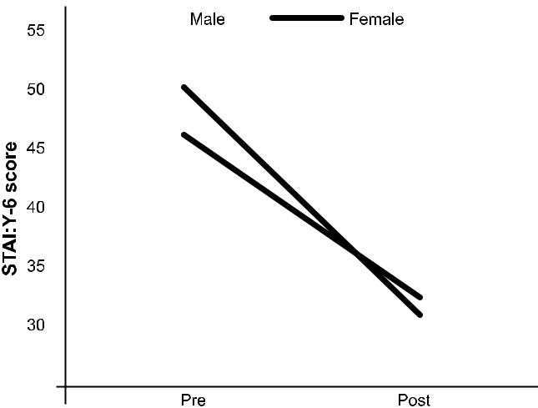

SD: standard deviation; STAI: Y-6: shortened form of Spielberger State-Trait Anxi-

ety Inventory.

Fig. 2. Gender difference of STAI: Y-6 within the weighted blanket group. STAI: Y-6:
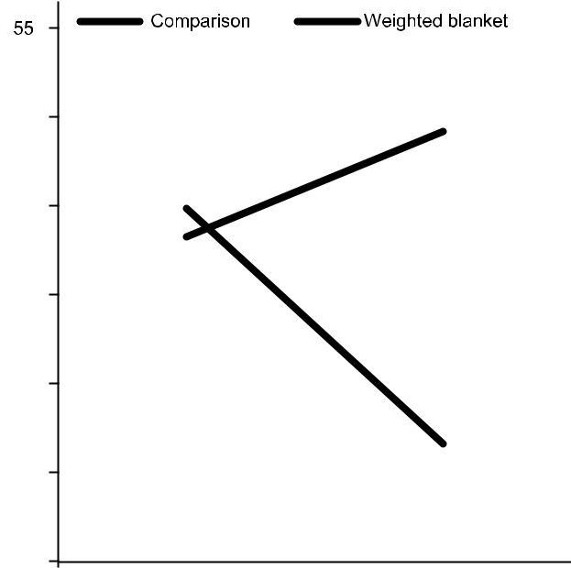

shortened form of Spielberger State-Trait Anxiety Inventory.
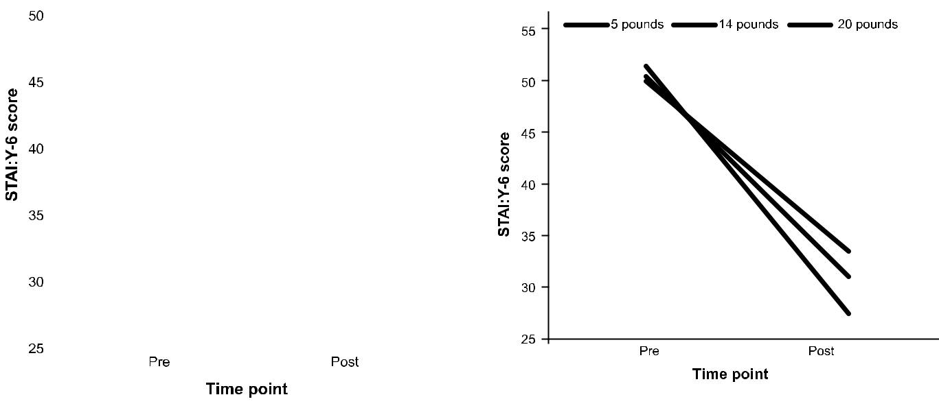

Fig. 1. Pre- and post-intervention scores of STAI: Y-6 in both groups. STAI: Y-6:

shortened form of Spielberger State-Trait Anxiety Inventory.

Fig. 3. Pre- and post-intervention scores of STAI: Y-6 within the weighted blanket group with different blanket weight. STAI: Y-6: shortened form of Spielberger State-Trait Anxiety Inventory.

132

A.L. Becklund, L. Rapp-McCall and J. Nudo Journal of Integrative Medicine 19 (2021) 129–134
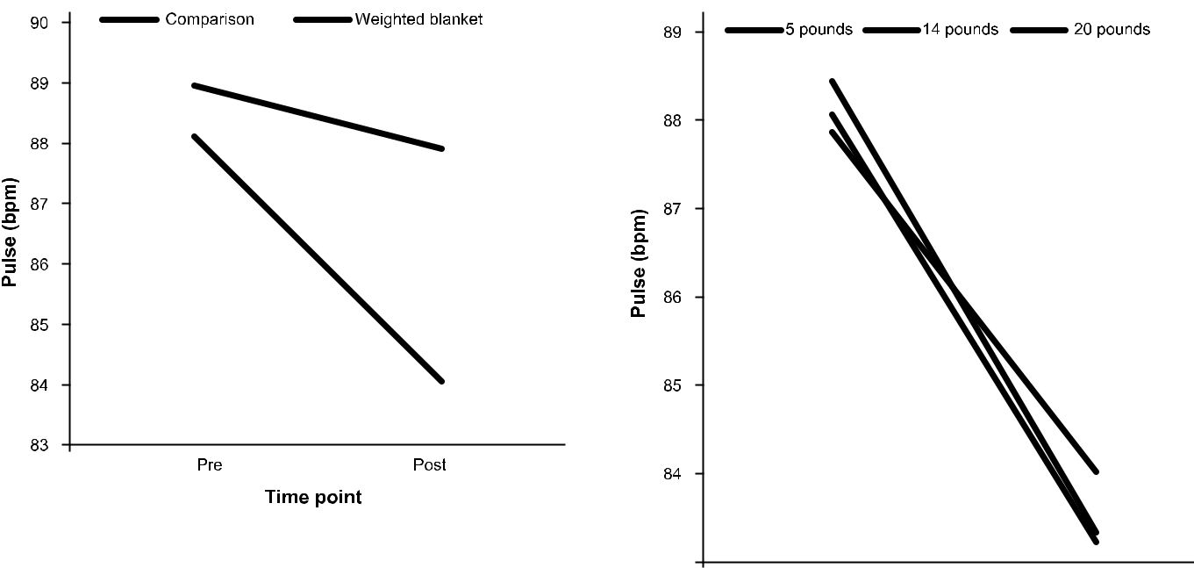

Fig. 4. Pre- and post-intervention pulse results with and without use of weighted blanket. bpm: beats per minute.

group, no significant interaction effects were found by gender (F_{[1,57]} = 2.333, P = 0.132, partial = 0.039; Fig. 5) or blanket weight (F_{[2,56]} = 0.164, P = 0.849, partial g² = 0.006; Fig. 6).

4. Discussion

This study found that use of a 14-pound or 20-pound weighted blanket or a 5-pound lap pad for approximately 20 min signifi-cantly decreased anxiety and pulse rate in adults experiencing anx-iety in an inpatient mental health unit. The comparison group, who did not use a weighted blanket or lap pad, did not exhibit a statis-tically significant reduction in pulse rates or anxiety scores. In fact, their STAI: Y-6 scores increased between pre- and post-intervention assessments. The reduction in anxiety by the group who used a weighted blanket was consistent with the findings of both studies conducted in 2008 and 2015 [6,8] and was indepen-dent of the weight of blanket used. Our study found no differences in results based on demographics, in that gender and age did not impact results. Our study also did not encounter any safety con-cerns for patients. These results add to our knowledge of the safety and effectiveness of weighted blankets.
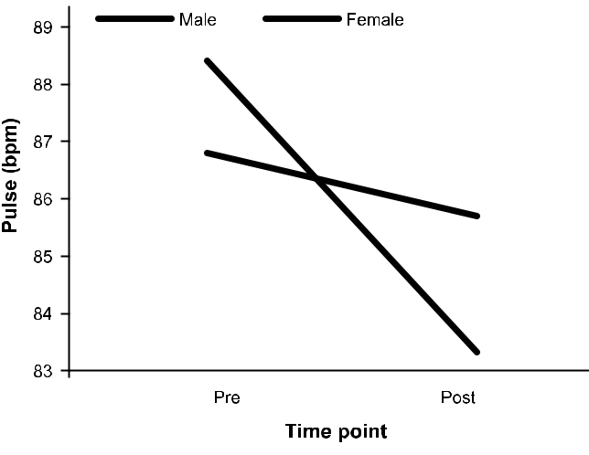

Fig. 5. Pre- and post-intervention pulse rates by gender. bpm: beats per minute.

Fig. 6. Pre- and post-intervention pulse rates by weight of blanket used. bpm: beats per minute.

There were some limitations to the study. The environment in the inpatient unit was not totally controlled. Patients who used the weighted blanket or lap pad were in their rooms with room-mates and were not free of interruptions. There was no climate control, and at times, the rooms were very warm. In addition, the study did not control for the administration of medication before, during or after use of the weighted blanket; this may have had effects on pulse rates and anxiety levels, although patients in the comparison group may also have been administered medications.

This study did not weigh patients before offering a weighted blanket, so the blanket may not have been approximately 10% of their weight. Instead, patients were offered their choice of weighted blankets, and most of the patients choose the 14-pound blanket. Those patients who could not tolerate a blanket but still wanted to participate had the option of a 5-pound lap pad. Offering freedom of choice made the study more patient-centered but may have affected the outcome.

The primary researchers were a licensed clinical social worker and a graduate social work student intern. The presence of a ‘‘ther-apist” during use of the weighted blanket may or may not have provided additional comfort. Just being present can have its own therapeutic effect [11].

5. Conclusion

Further research studies are needed to follow patients after dis-charge and measure anxiety, effects of medication use, and/or fur-ther use of the weighted blanket. Additional studies in care facilities should also control for medication usage before and after weighted blanket use, as well as any effects on the use of sedatives and/or physical restraints.

In addition, staff training is necessary to ensure safety and encourage the use of weighted blankets in lieu of typical methods. Staff should receive one hour of training in the use of weighted blankets during their employee orientation. It is recommended that employees should be given the opportunity to try out the weighted blanket to feel and experience its effects first-hand.

133

A.L. Becklund, L. Rapp-McCall and J. Nudo

There was a statistically significant drop in anxiety for adults in an inpatient facility, as evidenced by the STAI: Y-6 scores and a drop in pulse rates for those using weighted blankets. This repli-cates previous studies and suggests a possible alternative to med-ications, seclusion, and physical restraints, which are not patient-centered or conducive to trauma-informed care.

Funding

Oglethorpe, Inc. provided partial funding to conduct the study, but had no involvement in the design, data collection, analysis, writing, and/or submission of the manuscript for publication.

Author contributions

ALB designed the hypotheses and the experiments with the consultation and guidance of LRM. ALB and JN (supervised by ALB) used weighted blankets, facilitated the comparison group and collected anxiety measurements including measuring pulse and the STAI: Y-6 inventory as well as all data collection. LRM coor-dinated the data analysis via SPSS. All authors participated in data interpretation and manuscript review and writing. All authors were responsible for preparation of the tables and figures. All authors contributed to the scientific discussion of the data and of the manuscript.

Declaration of competing interest

The authors declare that they have no known competing finan-cial interests or personal relationships that could have appeared to influence the work reported in this paper.
Journal of Integrative Medicine 19 (2021) 129–134

Acknowledgment

The authors wish to thank John Picciano, Robert Lucio, Barbara Kerr, Sarah Dudley, and Evelyn Salvatore.

References

- National Alliance on Mental Illness. Anxiety disorders. (2017-12) [2020-01-01]. https://www.nami.org/About-Mental-Illness/Mental-Health-Conditions/ Anxiety-Disorders.
- National Institute of Mental Health, U.S. Department of Health and Human Services. Anxiety disorders. (2018-07) [2020-01-01]. https://www.nimh. nih.gov/health/topics/anxiety-disorders/index.shtml.
- Sweeney A, Filson B, Kennedy A, Collinson L, Gillard S. A paradigm shift: relationships in trauma-informed mental health services. BJPsych Adv 2018;24
(5):319–33.

- Tuthill JC, Azim E. Proprioception. Curr Biol 2018;28(5):R194–203.

- PTSD Journal. Sleeping with weighted blanket helps insomnia and anxiety, study finds. (2016-01) [2020-07-02]. https://www.ptsdjournal.com/posts/ sleeping-with-weighted-blanket-helps-insomnia-and-anxiety-study-finds/.
- Mullen B, Champagne TT, Krishnamurty S, Dickson D, Gao RX. Exploring the safety and therapeutic effects of deep pressure stimulation using a weighted blanket. Occup Ther Ment Health 2008;24(1):65–89.
- Grandin T. Calming effects of deep pressure in patients with autistic disorders, college students, and animals. J Child Adolesc Psychopharmacol 1992;2
(1):63–72.

- Champagne TT, Mullen B, Dickson D, Krishnamurty S. Evaluating the safety and effectiveness of the weighted blanket with adults during an inpatient mental health hospitalization. Occup Ther Ment Health 2015;31(3):211–33.
- Sensory Goods. Sensory goods offering affordable therapy products, affordable weighted blankets. [2020-01-01]. http://sensorygoods.com/products/medical-weighted-blankets.

- Marteau TM, Bekker H. The development of a six-item short-form of the state scale of the Spielberger State-Trait Anxiety Inventory (STAI). Br J Clin Psychol 1992;31(3):301–6.

- Ackerman SJ, Hilsenroth MJ. A review of therapist characteristics and techniques positively impacting the therapeutic alliance. Clin Psychol Rev 2003;23(1):1–33.

134

